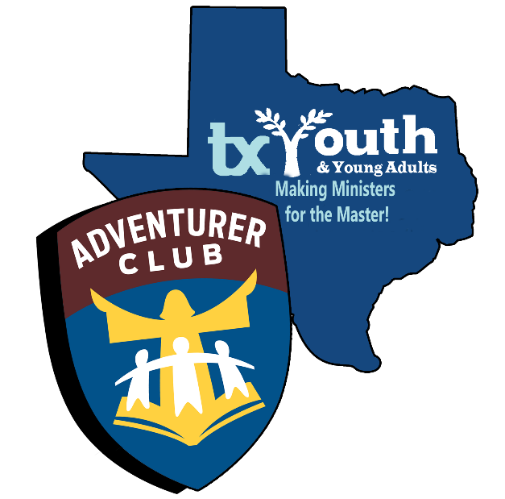

CLUB NAME
ADVENTURERS

INDUCTION PROGRAM

Processional: Adventurer Theme Song (Please Stand)
Color Guard:

Adventurer Pledge:
Adventurer Law:
Bible:
Helping Hands:
Builders:
Sunbeams:
Busy Bees:
Eager Beaver:
Little Lambs:

Pledge of Allegiance:
Pledge to Christian Flag
Pledge to the Bible:
Adventurer Song:
Opening Prayer:
Welcome
Significance of Alter:
Significance of Adventurer Law:
Adventurer Pledge and Law:
(All Adventurers Stand and Recite)
Director’s Declaration:
Conference Declaration:
Induction
Parent’s Pledge:
Dedication Prayer:

Recessional: Adventurer Theme Song

Adventurer Pledge:

“Because Jesus loves me,
I will always do my best.”

Adventurer Law
Jesus can help me to:
Be Obedient
Be Pure
Be True
Be Kind
Be Respectful
Be Attentive
Be Helpful
Be Cheerful
Be Thoughtful
Be Reverent

Adventurer Song

We are Adventurers,
At home, at school, at play,
We are Adventurers,
We’re learning every day,
To be honest, kind and true,
To be like Jesus, through and through,
We are Adventurers!!!!

